Parts list
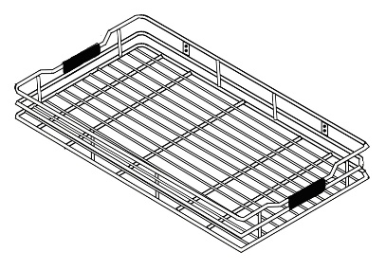  #1 | 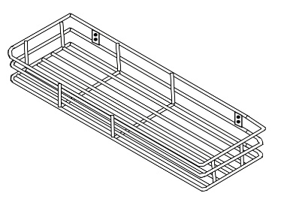  #2 | 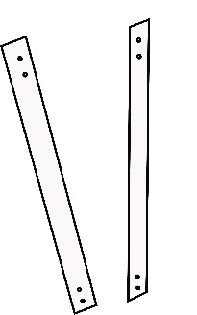  #3
#4  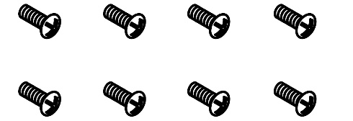 | #5  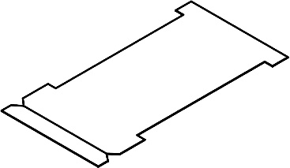 | 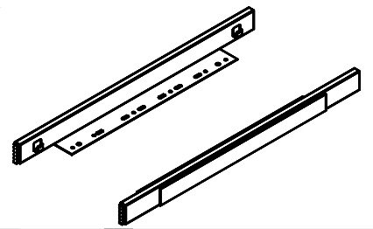  #6
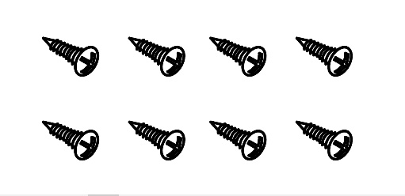  #7 | 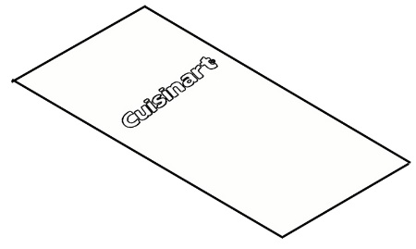  #8 | 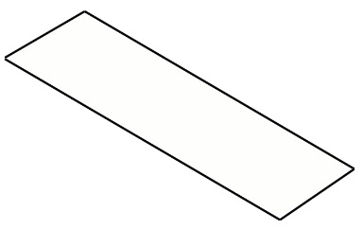  #9

DESCRIPTION | QTY
#1. Bottom wire basket | 1
#2. Upper wire basket | 1
#3. Support brackets | 2
#4. 3/8” bolts | 8
#5. Template | 1
#6. Gliders | 1 left side, 1 right side
#7. 5/8” screws | 8
#8. Bottom basket mat | 1
#9. Upper basket mat | 1
REQUIRED TOOLS
(not provided)
⊙ Drill
⊙ 1/8" Drillbit
⊙ Screwdriver

Installation Instruction
Step 1 | 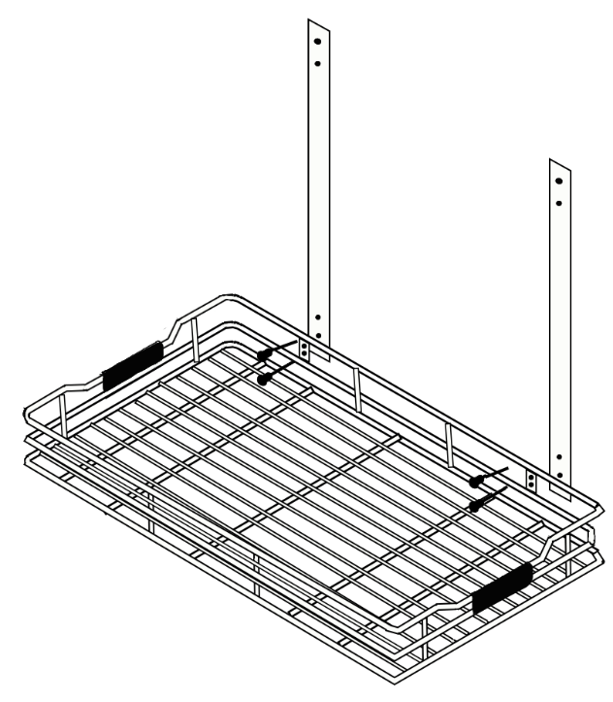  Place the support brackets (#3) outside of bottom wire basket (#1). Screw the 3/8” bolts (#4) from inside of bottom wire basket (#1) toward outside using screw driver.
Step 2 | 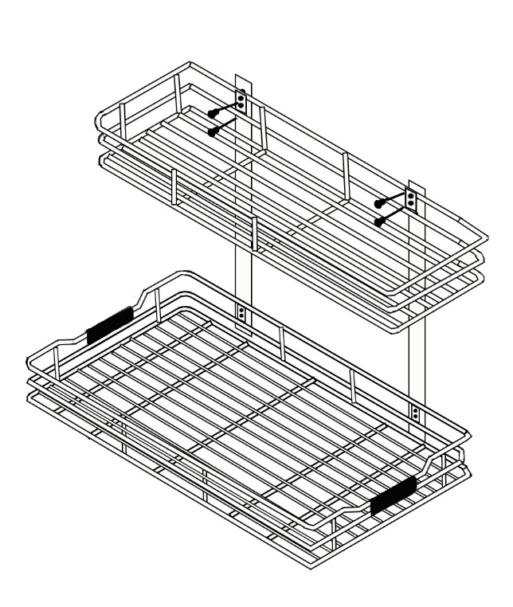  Place the upper basket (#2) against the supporting brackets (#3). Screw the 3/8” bolts (#4) from inside of upper wire basket (#2) toward outside using screw driver.
Step 3 | 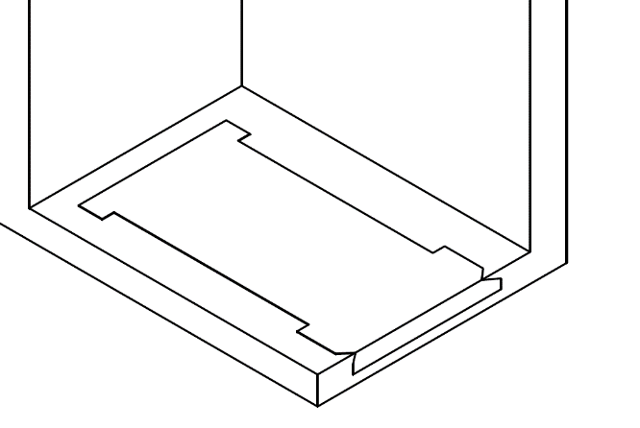  Fold the front edge of template (#5) along the line between the “V” cutouts and place inside the cabinet with folded edge at front edge of cabinet.
Step 4 | 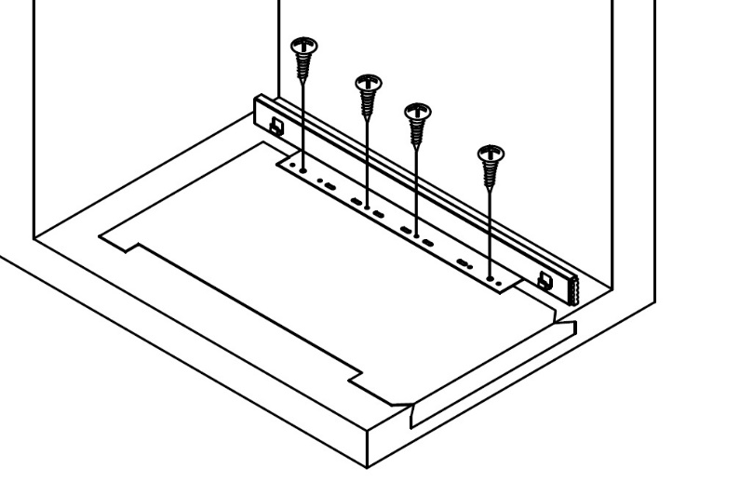  Place gliders (#6) in cutouts of template (#5). The edges of gliders should align with edges of cutouts. Drill 1/8” pilot holes through 4 holes in the glider (#6). Remove template after drilling pilot holes. Attach gliders (#6) to bottom of cabinet using 5/8” screws (#7) and screw driver. Repeat for the opposite side.
Step 5 | 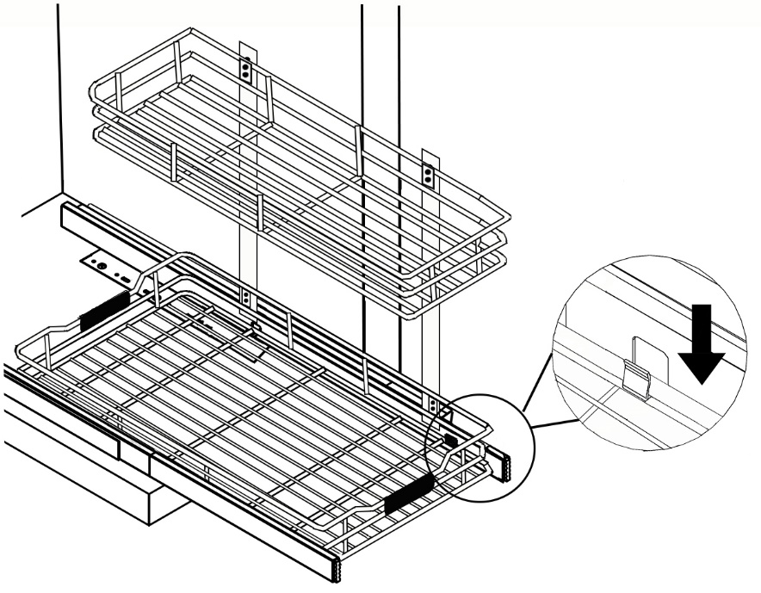  Remove and discard template (#5). Slide gliders (#6) forward and align lower rail of bottom wire basket (#1) with the clips on gliders (#6) and snap into place.
Step 6 | Place upper basket mat (#9) onto the upper wire basket (#2). Place bottom basket mat (#8) onto bottom wire basket (#1). Push the glider into cabinet.

